

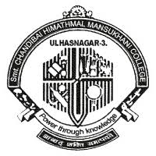

Smt. CHANDIBAI HIMATHMAL MANSUKHANI COLLEGE

ULHASNAGAR - 3
A
Project Report

On

“Ultrasonic Navigation System For Blind People”

For The Course
BSc. Computer Science

SUBMITTED BY
Jaydeep Dinesh Dhurat
(Roll No: 12)
Final Year Computer Science

GUIDED BY
PROF. Lata Bhatia

SUBMITTED TO

Smt. CHM COLLEGE
For Academic Year
2020-21

HEAD OF DEPARTMENT

PROF. Ritika Sachdev



THE PROCESS

This is a weekly report about project in the reference of first online presentation session held on 6-02-2021 under the guidance of prof. Lata Bhatia in which i presented description of my project
named as “Ultrasonic Navigation System For Blind People”

In that presentation, concerned guide suggested me one feature that I can include in my project (about GSM Module) but on to that I convinced her that if any of one electronic component or sensor will be adding in a system then the price and overall cost of the device will be much more as i am using raspberry-pi in the project and there will be no advantage of using this device as more efficient smart devices are available in the market at high value.

I am working on my project as am going to order required components within 2-3 days.

Thanks for Guidance and help!

